**Set up Borg MOEA in HRR manual**

By Dongmei Feng

Borg initial set up

1. 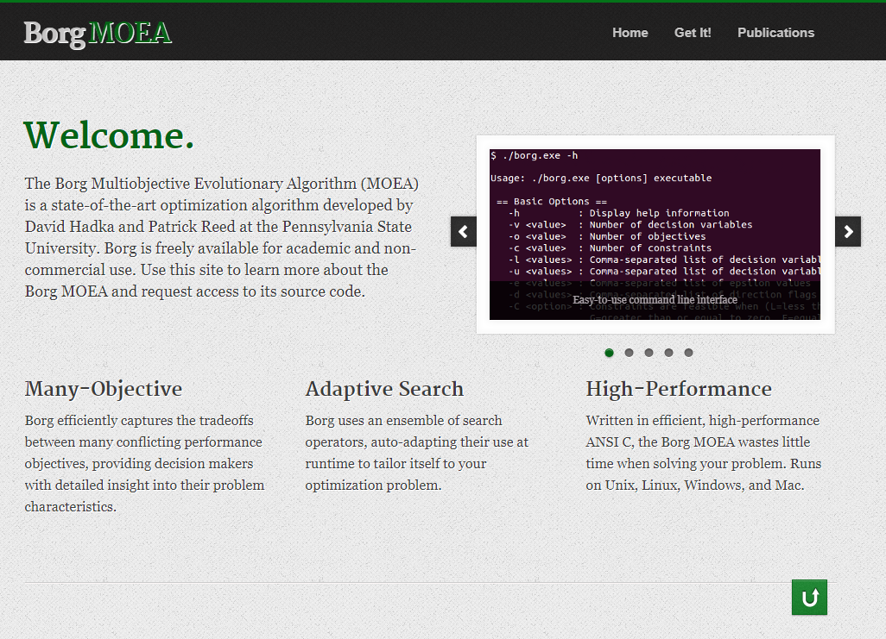Go to <http://borgmoea.org/>, create an account by clicking Get it! on the top panel

Fill out the following form and submit

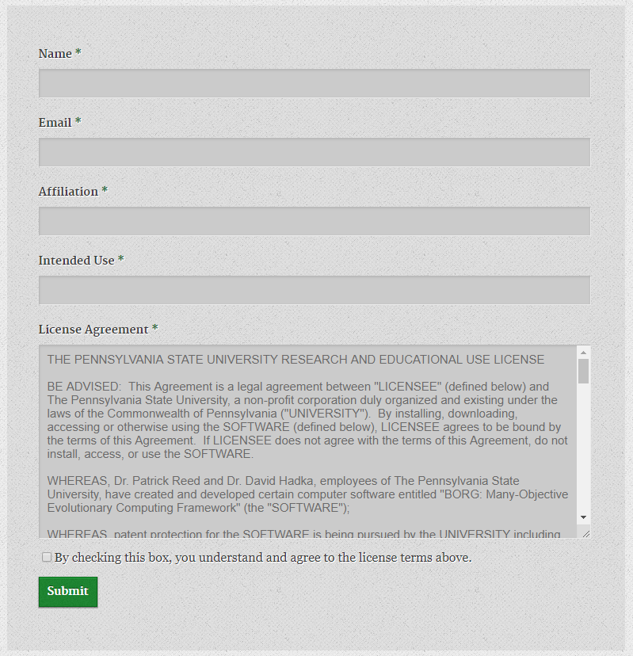

1. After creating this account, you will receive an email containing a link to the Borg MOEA repository. On the repository website, you can download the code, user guide and examples by clicking “Downloads” on the left panel.

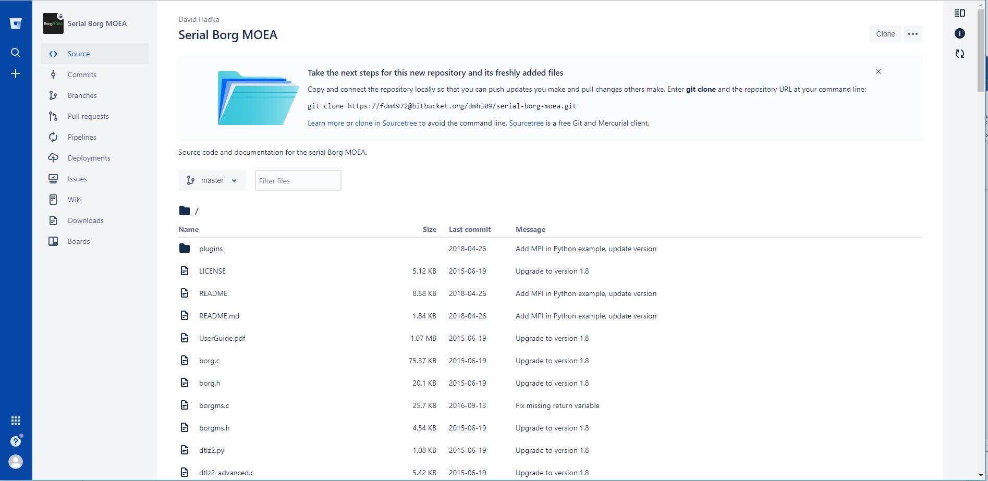

1. Open Visual Studio, create a **new,** **empty project** under **Visual C++.**

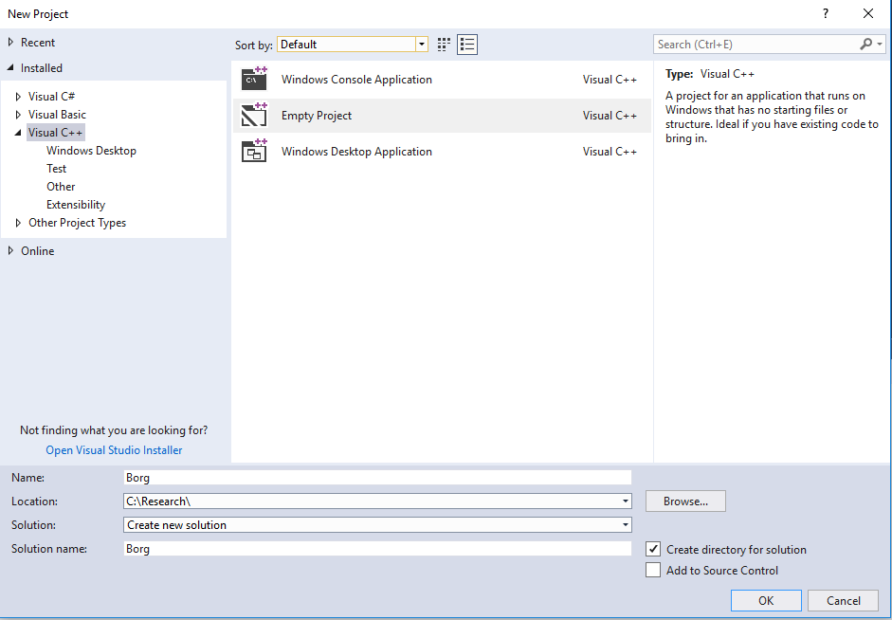

Then add borg.c, borg.h, mt19937ar.c and mt19937ar.h (these files are located in the package folder you downloaded from the repository) to the project. It should look like below:

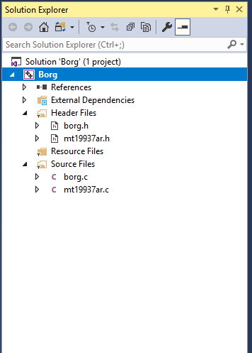

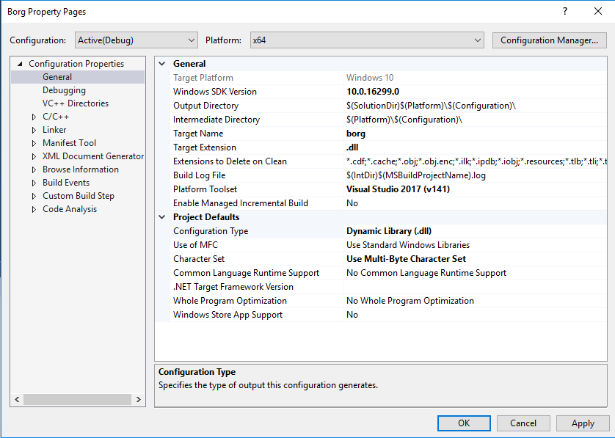Next, edit the project properties: right click **Borg ->Properties;** on the general page, change **Target Name** to **borg**, **Target Extension** to **.dll** and **Configuration Type** to **Dynamic Library (.dll)**. It should look like below:

Here, please check the version of python in your machine. If it is 64 bit, then make sure the Active solution platform and Configuration platform are x64 (see below); if your python is 32 bit, then change the Active solution platform to x86 and Configuration platform to Win32

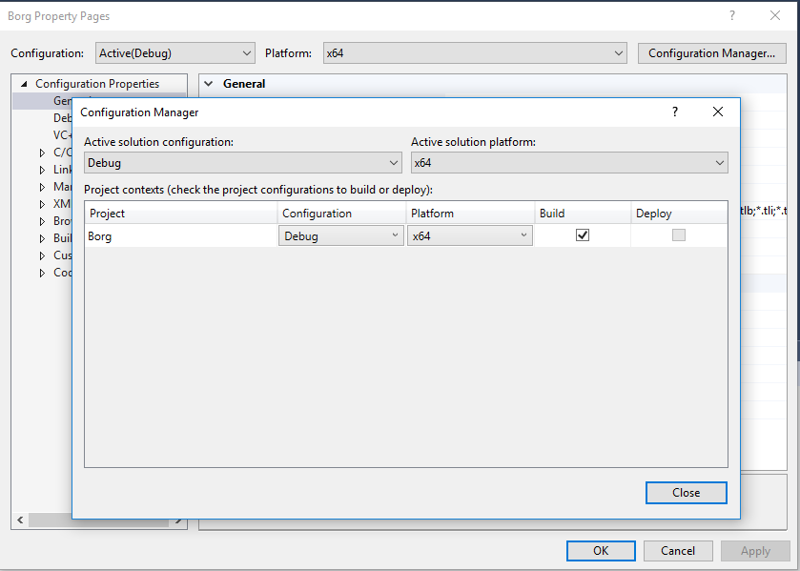

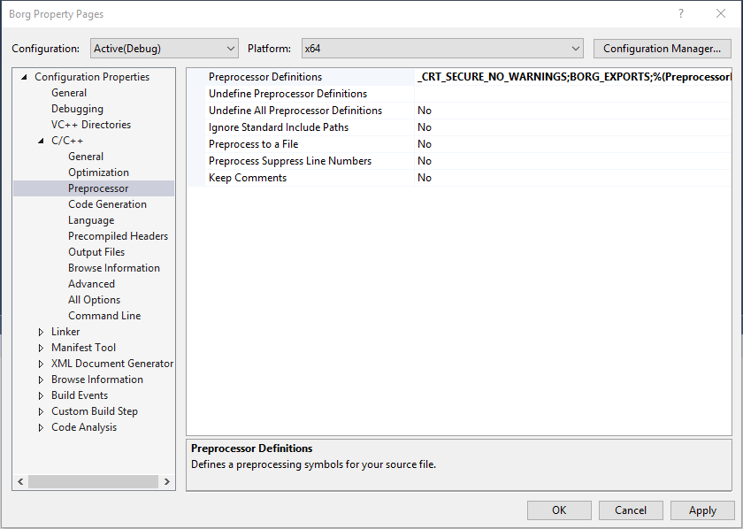Then go to C/C++ ->Preprocessor page, add _CRT_SECURE_NO_WARNINGS and BORG_EXPORTS to the Processor Definitions.

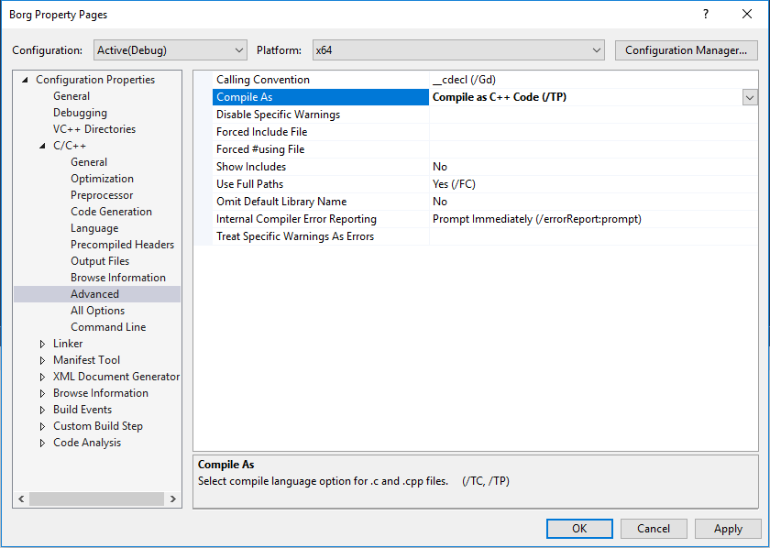Next, go to the C/C++ ->Advanced page, change **Compile As** to **Compile as C++ Code (/TP)**

1. After all these properties are set, click OK. Then build the borg.dll by right clicking Borg->Build. If everything is correct, the output window should look like below. You can find the borg.dll at the path highlighted below.

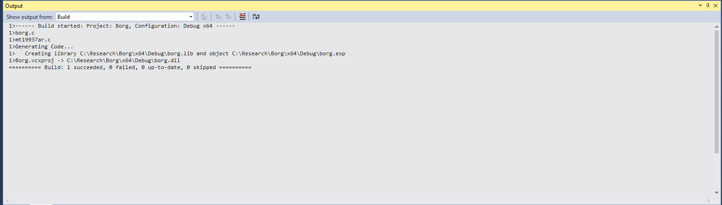

You have compiled the borg successfully in your computer. Now it is ready to connect borg with HRR.

HRR-BorgMOEA set up

1. Copy borg.dll to the folder containing HRR code and inputs files
2. Compile HRR. I recommend run HRR at least once to check the outputs are correct
3. Make a copy of file ‘input_num.txt’ and name it ‘input_num1.txt’. this step is to back up the original format of input file because the input_num.txt will be changed when running HRR-BorgMOEA. Please make sure the content in the input_num1.txt is in the format: number followed by its definition, separated by space. For example, “3000 Khss_all”
4. Update the HRR-BorgMOEA.py

* Change the working directory in line 7 to your HRR folder:

For example, os. chdir("C:\Research\HRR-BorgMOEA")

* change nvars and nobjs to the number of parameters and objective functions, respectively.

For example,

nvars = 6

nobjs = 5

* Change the pos to the position of parameters (line numbers) in input_num.txt

For example, pos = [10,11,67,68,70,71]

* Change error_file to the name of file containing error metric outputs

for example, error_file = 'bestpara_00100_00_00_1984.txt'

* Please make sure the HRR executable is named as “run.exe”; if it is in a different name, please change the line 37: os.system("run.exe") correspondingly
* Borg is minimizing the objective functions, so if maximum objective functions are desired, such as NSE, please change them to negative, as done in line 51.
* Change line 51 to the position of error metrics in error_file
* Set parameter boundaries in line 60:

For example, borg.setBounds([10,200],[1,20],[0.001,5],[0.001,5],[0.01,20],[-10,0])

* Set epsilons in line 62. Epsilons are the thresholds of objective improvement under which the optimization will be terminated
* The lines needing modification are highlighted in the following screenshots:







